 | 26.9.9 Editors - Geometry Nodes Editor - Header - Add Modifier Menu - Hair - Utility modifiers
Table of content
Detailed table of content 1
Hair - Utility modifiers 2
General functionality 2
Attach Hair Curves to Surface 3
Redistribute Curve Points 4
Restore Curve Segment Length 4

Detailed table of content
Detailed table of content
Detailed table of content 1
Hair - Utility modifiers 2
General functionality 2
Output Attributes 2
Internal Dependencies 3
Bake 3
Named Attributes 3
Attach Hair Curves to Surface 3
Surface 3
Surface UV Map 3
Surface Rest Position 3
Sample Attachment UV 3
Snap to Surface 3
Align to Surface Normal 3
Blend along Curve 3
Output Attributes 4
Surface UV Coordinate 4
Surface Normal 4
Internal Dependencies 4
Named Attribute 4
Redistribute Curve Points 4
Factor 4
Feature Awareness 4
Restore Curve Segment Length 4
Selection 4
Factor 4
Reference Position 4
Pin at Parameter 4
Output 5
Curves 5
Internal Dependencies 5
Named Attribute 5

Hair - Utility modifiers

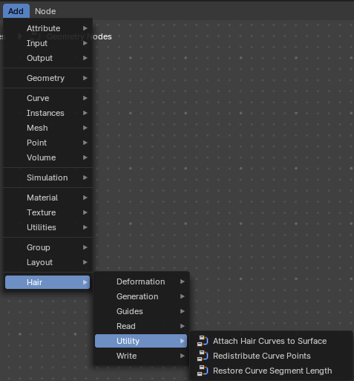
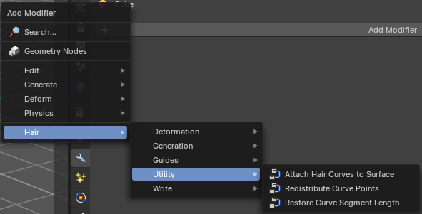
Hair nodes are Geometry node groups found in the Essentials Library included with Bforartists. They differ from the other nodes in the add menu due to being mid level node groups instead of individual low level nodes.
These hair nodes are also available as Modifiers. And this modifier adds the same node group as you would do it in the geometry node editor. Which means you can control these node groups in the modifier stack now instead of the geometry node editor.
Note that hair curves is usually a mesh only functionality. But shows for all other object types too.


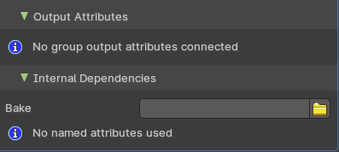
General functionality
All Hair nodes have an Output Attributes and Internal dependencies tab. If the hair node has output attributes or internal dependencies depends of the hair node.

Output Attributes
Contains group output attributes in case the node group has any. It is usually the output of the nodes besides the geometry.

Internal Dependencies

Bake
Define a bake name and a bake folder.
TODO: find out how this is meant to work.

Named Attributes
Named attributes of the hair node group in case the group has any.

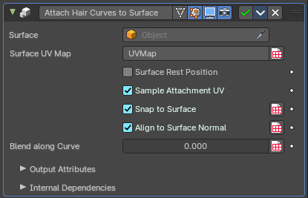
Attach Hair Curves to Surface
Attaches hair curves to a surface mesh.

Surface
Surface geometry to attach hair curves to.

Surface UV Map
Surface UV Map used to attach hairs to.

Surface Rest Position
Set the surface into rest position before attachment.

Sample Attachment UV
Sample the surface UV mapp at the attachment point.

Snap to Surface
Snap the root of the curve to the closest surface point.

Align to Surface Normal
Align the curves to surface normals. Needs a guide as reference.

Blend along Curve
Blend deformation along eacah curve from the root.

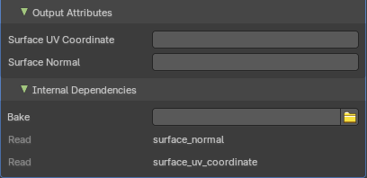
Output Attributes

Surface UV Coordinate
Surface UV Coordinate at the attachment point.

Surface Normal
Surface Normal at the attachment point.

Internal Dependencies

Named Attribute
Read attribute with name surface_normal.
Read attribute with name surface_uv_coordinate.

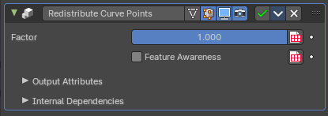
Redistribute Curve Points
Redistributes existing control points evenly along each curve.

Factor
Factor to blend overall effect.

Feature Awareness
Use simple feature awareness to keep feature definition.

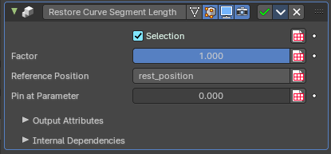
Restore Curve Segment Length

Selection
A selection of the input curve.

Factor
Factor to blend overall effect.

Reference Position
Reference position before deformation.

Pin at Parameter
Pin each curve at a certain point for the operation.

Output

Curves
The output curves.

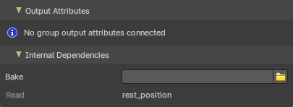
Internal Dependencies

Named Attribute
Read attribute with name rest_position.

